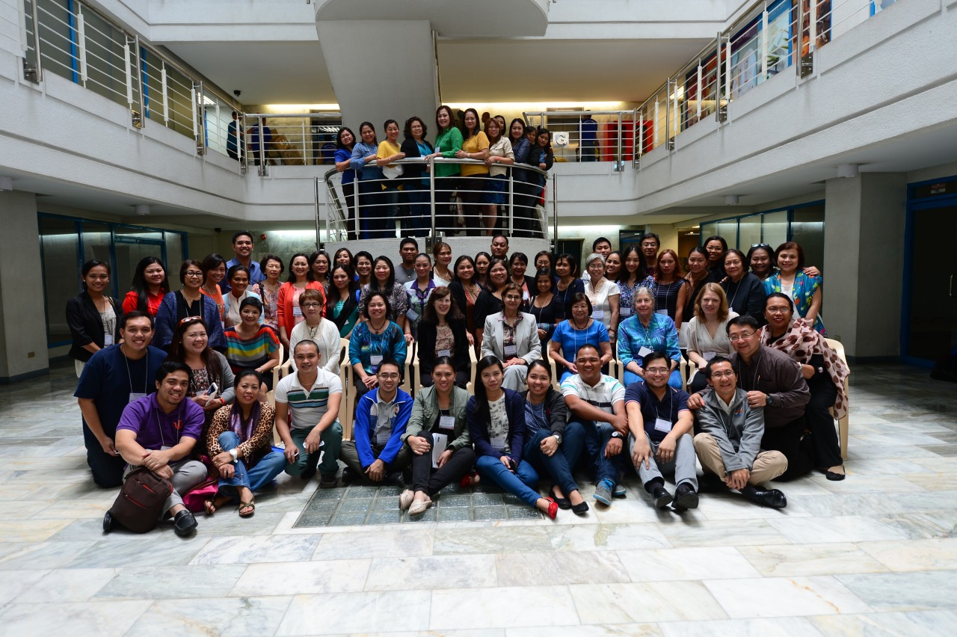

PHYCHOSOCIAL WORKSHOP REPORT
Manila, Philippines
January 2014

Planning

The workshop was organized over a period of five weeks and most planning was accomplished via emails between Drs. Ribaya and Olness. A final planning face to face meeting was held in Manila on January 15 with Drs. Ribaya, Olness, Lopez,Madrid, San Agustin, Holsinger, Esmaili and Ms. Barrera and Ms. Tica.

Sponsors(in alphabetical order):

Child Protection Unit Network- Philippines, Citizens Network for Psychosocial Response- Philippines, Department of Health-MHPSS cluster- Philippines, Health Frontiers-USA, Health Futures inc.- Philippines, International Pediatric Association, Khon Kaen University-Thailand, Medical Action Group-Philippines, Miriam College- Philippines, National Center for Culture and the Arts- Philippines, National Center for Mental Health- Philippines, Pediatrica and Unilab - Philippines, Philippines Ambulatory Pediatric Association, Philippines Science High School.

WORKSHOP PROGRAMME

Day 1 | January 16, 2014
Goals and Objectives

Participants will be able to:
- Describe short term and long term special issues that children experience in disasters.
- Describe appropriate interventions to help children in disasters.
- Describe problems of persons who work in disasters.
- List appropriate interventions to help relief workers.
- Describe the “Return to Happiness” program for children.
- List books which may be helpful to children after disasters.

08.00-08:15 |  | Invocation/ Pretest
08:15-08:40 |  | Overview effect of disasters on children and families. |  | Karen Olness
08:40-09:00 |  | Overview of MHPSS in the Philippines |  | June Lopez
09.00-09:30 |  | Explanation problem based learning |  | SriviengPairojkul
09:30-10.00 |  | Psychosocial issues for relief workers |  | Eva Holsinger
10:00-10:30 |  | Discussion case history #1
10:30-10:45 |  | Break
10:45-11:15 |  | Psychosocial triage |  | ChanyuthSuphakunpinyo
11:15-12:15 |  | Discussion case history #2
12:15-13:00 |  | Lunch break
13:00-13:30 |  | Child development: how children react at different stages of child development |  | ChanyuthSuphakunpinyo
13:30-14:30 |  | Discussion case history #3
14:30-15:00 |  | Return to happiness program |  | SriviengPairojkul
15:00-15:15 |  | Break
15:15-16:00 |  | The aftermath of the tsunami in Southern Thailand: how we helped children and families |  | SriviengPairojkul
16:00-17:00 |  | How books can help children and families in disasters |  | Bron Anders,  Mutya San Augustin, Carmen Bonoan
Day 2 | January 17, 2014
Goals and Objectives

Participants will be able to:
- Define PTSD and its treatment.
- Explain how children understand and cope with death.
- Describe positive and negative influences of media in disasters.
- Describe risks for abuse of children in the aftermath of a disaster.
- Demonstrate how to use biofeedback to help themselves.

08:00-08:30 |  | PTSD diagnosis and treatment | HaydehEsmaili
08:30-09:30 |  | Case history #4
09:30-10.00 |  | Tacloban personal experience from participants
10:00-10:15 |  | Break
10:15-10:45 |  | Coping with death: the special issues of children | ChanyuthSuphakunpinyo
10:45-11:45 |  | Case history #5
11:45-12:45 |  | Lunch
12:45-13:15 |  | The media in disasters | MahippathornChinnapha
13:15-14:15 |  | Case history #6
14:15-14:45 |  | Tacloban personal experiences from participants
14:45-15:00 |  | Break
15:00-15:30 |  | Abuse of children and child protection after disasters | Eva Holsinger
15:30-16:30 |  | Case history #7

Day 3 | January 18, 2014
Goals and Objectives

Participants will be able to:
- Describe school problems related to disasters
- Describe interventions to help orphans.
- Describe long term issues for bereaved parents.
- List the long term psychosocial effects of malnutrition.

08:00-08:30 |  | The Way Forward | Honey Carandang
08:30-09:00 |  | Schools: How to help students and teachers | MahippathornChinnapha
09:00-09:45 |  | Case history #8
09:45-10:15 |  | Art to Reinforce Resilience in Children in Disaster Situations | LutgardoLabad
10:15-10:30 |  | Break
10:30-11:00 |  | Long term issues for orphans: How to help them | SriviengPairojkul
11:00-11:45 |  | Case history #9
11:45-12:15 |  | Long term issues for parents who have lost children: How to help them? | HaydehEsmaili
12.15-13.00 |  | Lunch
13:00-13:45 |  | Case history #10
13:45-14: 15 |  | Psychosocial effects of malnutrition | Karen Olness
14:15-15:15 |  | General discussion what can we all do to help children and families following disasters in the Philippines? | Bernadette Madrid
15:15-15:45 |  | Summation of Workshop
15:45-16:00 |  | Post test
16:00-16:30 |  | Certificate ceremony

